Bactericidal polymer produced from recycled plastic waste and zinc oxide nanoparticles using electromagnetic induction heating for its transformation into usable objects.
Harry Anderson Rivera Tito, Pilar Amalia García Avelino y María Esther Quintana Cáceda
Abstract
The polymeric material produced from recycled polyethylene terephthalate (PET) and polypropylene (PP) flakes and surface-decorated with zinc oxide (ZnO) nanoparticles through an electromagnetic induction field exhibited photochemical activity against the cell membrane of Escherichia coli (E. coli), a common bacterium frequently found in contaminated food and water. These results demonstrate that materials integrated into the circular economy can be repurposed for different sectors that require emerging products with advanced properties capable of generating adverse effects on the cell wall membranes of microorganisms. This approach helps reduce the excessive use of detergents and water for disinfection, the latter being a highly valuable resource in regions affected by climate change.
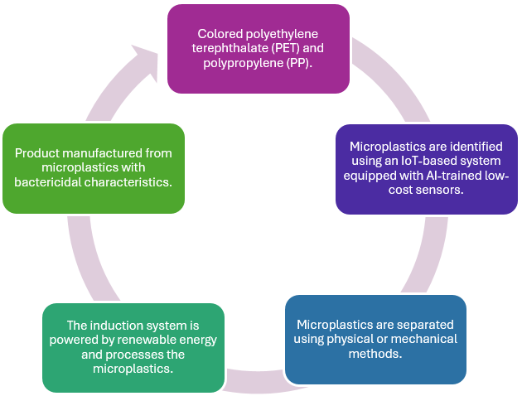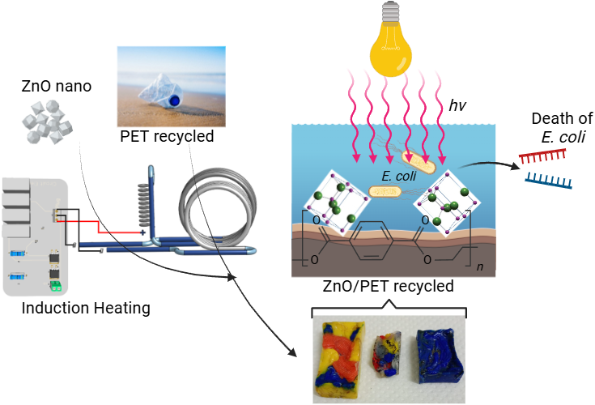
Figure 1. Summary diagram showing all components associated with the photoactive activity of ZnO/PET against Escherichia coli (E. coli).
Introduction
Over the past few years, plastics have been the focus of both positive and negative attention worldwide. Since their invention in 1907 by the Belgian chemist Leo Hendrik Baekeland [1, 2], plastics have become indispensable materials for industry due to the high demand for everyday products used in daily activities, ranging from cleaning products to food packaging. [3] In addition, other types of plastics are indirectly integrated into everyday life through clothing, electrical and electronic equipment, medical prostheses, household utensils, civil infrastructure, and many other applications. [4, 5]
As a consequence of the versatility and extensive use of plastics over recent decades, concerns have emerged regarding their biomagnification in the environment due to their fragmentation under weather conditions and exposure to mechanical forces such as friction with other environmental components after disposal. [6–8] Within this context, polyethylene terephthalate (PET) stands out as a polymer with excellent physical properties, including optical transparency and mechanical strength. These characteristics have made PET the most widely used among the seven categories of recyclable plastics, corresponding to recycling code number 1. [9–11] However, nano- and microscale PET fragments have been detected in rivers, oceans, glaciers, lakes, soils, air, clouds, and living organisms, becoming an environmental contaminant that threatens both human health and ecosystem quality. [12–14]
To mitigate its impact, numerous strategies have been proposed, ranging from recycling processes to biodegradation using beneficial microorganisms, involving governmental, industrial, and academic sectors. These efforts have increased environmental awareness by incorporating plastics into circular economy frameworks and have stimulated the search for alternative polymers derived from natural raw materials that exhibit rheological properties similar to those of PET. [15–17] Although a variety of technologies have emerged to gradually reduce the environmental impact of PET, they do not eliminate its monomeric components, which may eventually become a significant environmental liability in landfills and waste disposal sites. [18]
To avoid this scenario, the transformation of recycled PET [19] requires the development of technological alternatives that are less complex, easy to operate, cost-effective, and powered by renewable energy sources. [20–22] Furthermore, new applications for recycled plastic materials must be explored to increase their added value and encourage greater public participation in recycling programs.
During the last decade, numerous thermal technologies have been employed to transform PET into useful products. However, most of these technologies fail to satisfy the aforementioned requirements, and some still rely on fossil fuels or natural gas as heat sources, while also consuming significant amounts of water during mechanical processing. In contrast, magnetic induction heating and Joule heating technologies offer a promising sustainable alternative because they can be powered by renewable electricity sources. [23, 24] Compared with conventional thermal processes, these technologies can operate at relatively low voltages and with direct current supplied by renewable energy systems, thereby enabling a more environmentally friendly transformation of polyolefins.
Various electromagnetic induction systems have been developed since the discovery of electromagnetic induction by Michael Faraday in 1831. These systems are mainly classified according to the type of induction solenoid coil, operating power, and frequency employed. [25] Due to their operating principle, electromagnetic induction systems generate magnetic fields around the coil windings, altering the spin orientation of ferromagnetic materials. [26, 27] Such materials generally heat up when placed at the center of the coil, reaching temperatures of approximately 1150 °C. [25] This thermal energy can be effectively transferred to PET through heat conduction, modifying its malleability and facilitating the incorporation of additives that provide additional functionalities.
In recent years, the healthcare sector has demanded polymeric materials with diverse functionalities, ranging from respiratory protective masks (with mesh diameters of approximately 10 µm) to automated ventilators predominantly manufactured from plastics. [28] Nevertheless, protection in highly populated indoor environments remains critically important. Consequently, bactericidal materials, such as stainless steel used in restrooms, handrails, and door handles, have been increasingly adopted. [29–31] Despite their relatively high cost, their benefits justify their widespread use.
On the other hand, nanoparticles have emerged as promising tools in biotechnology for the elimination of various bacterial species. For example, Vishvanath Tiwari et al. [32] employed ZnO nanoparticles to induce dysfunction in Acinetobacter baumannii. In this context, ZnO-mediated photocatalytic degradation occurs when the semiconductor is irradiated with light possessing energy greater than its bandgap energy. Light absorption triggers charge separation by exciting electrons from the valence band to the conduction band, leaving holes in the valence band. The photogenerated electron-hole pairs (e⁻/h⁺) subsequently migrate to the ZnO surface. Simultaneously, electron-hole recombination may occur, reducing the quantum efficiency of the process. The recombination rate is influenced by several factors related to photocatalyst structure and surface modifications.
The reactive electrons and holes that reach the ZnO surface promote oxidation and reduction reactions, generating reactive oxygen species (ROS), including superoxide radicals (•O₂⁻) and hydroxyl radicals (•OH). The conduction band edge of ZnO (−0.5 V versus the normal hydrogen electrode, NHE) is more negative than the redox potential of the O₂/•O₂⁻ couple, allowing excited electrons to generate superoxide radicals. Simultaneously, the valence band edge of ZnO (+2.7 V vs. NHE) is more positive than the redox potential of the •OH/H₂O couple (+2.53 V vs. NHE), enabling water molecules to be oxidized into hydroxyl radicals. These highly reactive radical species directly oxidize organic contaminants and can also damage bacterial cell membranes, ultimately leading to cell death. [33]
Therefore, this project addresses the eco-efficient thermal transformation of PET using a microplastic detection system (PET and PP) based on Internet of Things (IoT) technology, low-cost sensors, and artificial intelligence algorithms. The proposed system incorporates a portable electromagnetic induction device containing a ferromagnetic material that transfers heat to PET and PP through thermal conduction, ensuring their melting. Subsequently, the softened polymeric material is coated with ZnO nanoparticles to produce a bactericidal recycled plastic material with enhanced functional properties.
Methodology
Electromagnetic Induction Heater Structural Electronics
The induction heating system consisted of two IRFZ44N MOSFETs, two 1 kΩ (½ W) resistors, two 150 Ω (2 W) resistors, five 0.33 µF × 250 V MKP capacitors, and three coils made of rigid enameled copper wire with a cross-sectional area of 4 mm², all acquired from Peruvian suppliers. The temperature inside the induction coil was measured using a FLUKE Ti480PRO infrared thermographic camera.
PET-PP Processing
Polyethylene terephthalate (PET) and polypropylene was collected from recycling bins labeled with the PET recycling symbol (code 1). The material was sorted by removing labels and other commercial markings, washed with ultrapure water without detergent, dried under ambient conditions, and ground to obtain flakes with an average particle size of approximately 2 mm in diameter.
Synthesis of ZnO Nanoparticles
Colloidal ZnO was prepared using a simplified version of previously reported methods. Eleven grams (50 mmol) of zinc acetate dihydrate (Merck) were stirred in 100 mL of absolute ethanol (99.5%, Kemetyl) at room temperature, resulting in an opaque suspension. Subsequently, 21 mL (50 mmol) of a 25% tetramethylammonium hydroxide (TMAOH) solution in methanol (Aldrich) was added.
The suspension was heated and maintained under reflux at 80 °C for 30 min. During heating, the solution became completely transparent; however, during reflux it gradually turned white again due to colloidal aggregation. The suspension was allowed to cool and settle overnight, after which it was decanted and washed with ethanol. This procedure was employed to reduce the concentration of tetramethylammonium acetate, which is essential for obtaining high-quality films. Finally, the ZnO colloid was concentrated until it became visibly viscous.
Physical Characterization of ZnO/PET-PP
Raman spectroscopy and Atomic Force Microscopy (AFM) analyses were performed using an NTEGRA II system (NT-MDT Spectrum Instruments) to evaluate the dispersion of ZnO nanoparticles on the architecture of the polymeric material molded using the induction heating system.
Escherichia coli (E. coli) Culture
The Escherichia coli ATCC 25922 strain was initially cultured in Brain Heart Infusion (BHI) broth and incubated for 18 h. The culture was subsequently transferred to nutrient broth and incubated for an additional 18 h to ensure viability and growth. For the experiments, an initial concentration of E. coli ATCC 25922 of 2 × 10⁸ Colony Forming Units (CFU) mL⁻¹ was used.
Photocatalytic and Bactericidal Evaluation of ZnO/PET-PP Against E. coli
To perform the bactericidal assays using PET-PP and ZnO/PET-PP samples, 100 mL beakers containing sterile buffered peptone water (20 g L⁻¹) were prepared. All inoculation experiments were conducted in triplicate for each sample (Table 1).
Table 1. Assays performed with E. coli under different experimental conditions.
Code | A | B | C | D
Assay | Dark condition (Control in the absence of light) | Photolysis | PET and PP | ZnO/PET-PP
Each beaker was maintained under continuous stirring at 200 rpm and room temperature (20 °C). A volume of 100 mL of bacterial suspension with a concentration of 2 × 10⁸ CFU mL⁻¹ was added to each beaker. In addition, to evaluate whether mechanical agitation affected bacterial viability, control experiments were conducted in the dark under stirring conditions (100 rpm) at room temperature. The photocatalytic system incorporated a 300 W Ultra-Vitalux lamp (Osram), which provided an irradiance of 60–65 mW cm⁻². The samples were exposed to this system for one hour, and 1 mL aliquots were collected every 15 min for each experiment. The aliquots were processed in saline solution (0.85% NaCl) through serial dilutions to reduce the inoculum concentration to 10⁻⁴. Subsequently, the diluted samples were transferred to sterile Petri dishes, inoculated by the pour-plate method using nutrient agar, and incubated at 40 °C for 24 h.
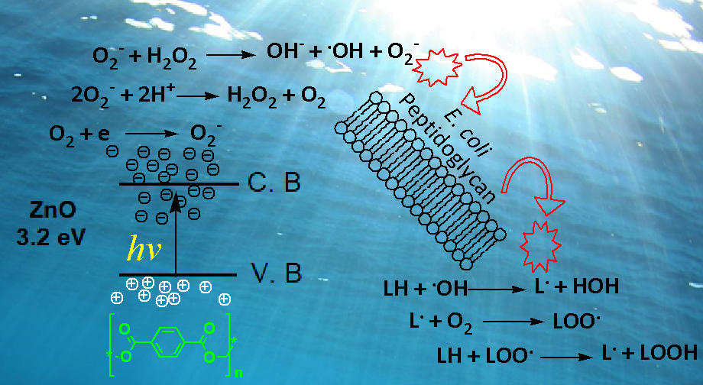
Figure 2. Proposed antibacterial mechanism of ZnO/PET against Escherichia coli (E. coli). The process involves the generation of highly reactive oxidative and reductive radical species that induce oxidative stress and structural damage to the peptidoglycan cell wall, ultimately resulting in bacterial inactivation and cell death.
Results and Discussion
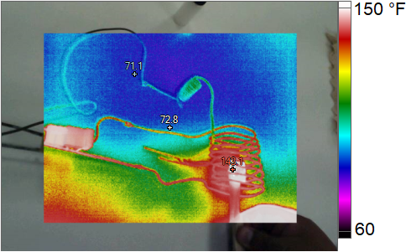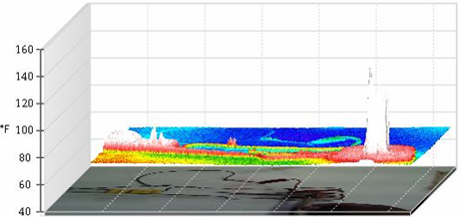
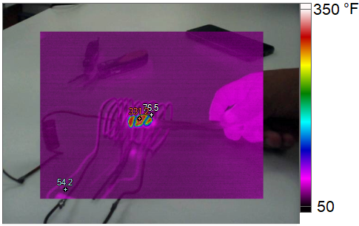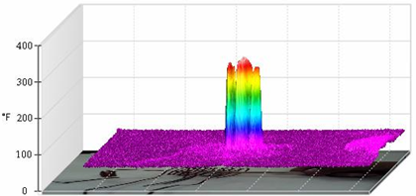
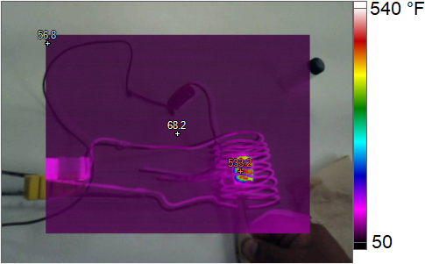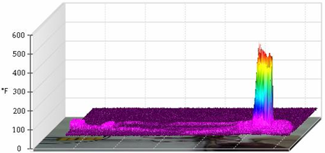
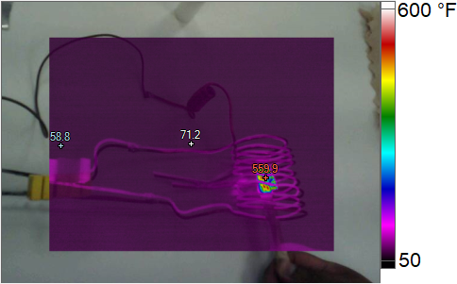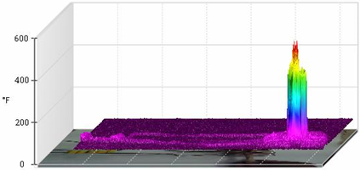
Figure 3. Thermographic images illustrating the temperature evolution of PET-PP within the ferromagnetic container positioned inside the copper induction coil before being coated with ZnO nanoparticles.
Figure 3 presents the thermographic images and three-dimensional temperature profiles obtained during the electromagnetic induction heating process of the PET–PP mixture contained within a ferromagnetic vessel. The results reveal a progressive increase in temperature as a function of heating time, demonstrating the effectiveness of the induction system in converting electromagnetic energy into thermal energy. Initially, temperatures close to 150 °F (approximately 65 °C) were recorded, with a relatively uniform thermal distribution across the system. As the heating process continued, localized hot spots developed within the ferromagnetic container, resulting in a significant increase in temperature and the formation of pronounced thermal gradients.
At intermediate stages, temperatures reached approximately 350 °F (177 °C), indicating efficient heat transfer from the ferromagnetic material to the polymeric matrix through thermal conduction. Under these conditions, the PET–PP mixture began to soften, facilitating its subsequent processing. Further heating increased the temperature to approximately 540 °F (282 °C), exceeding the melting temperature of PET-PP and promoting complete melting of the polymeric material. The highest temperatures were observed at the final stage of the process, reaching nearly 600 °F (315 °C). The corresponding three-dimensional thermal maps clearly show the concentration of heat within specific regions of the container, confirming the localized nature of induction heating.
The thermal behavior observed demonstrates that the electromagnetic induction system provides rapid and efficient heating while minimizing energy losses to the surrounding environment. This localized heating mechanism is particularly advantageous for the transformation of recycled plastics because it allows the polymer to reach processing temperatures without the need for direct combustion or conventional fossil-fuel-based heating systems. Furthermore, the complete melting of the PET–PP matrix generated a suitable surface for the subsequent incorporation and coating of ZnO nanoparticles, which are responsible for the bactericidal functionality of the final material. These findings suggest that electromagnetic induction heating represents a promising and sustainable approach for the valorization of plastic waste into high-value-added functional materials.
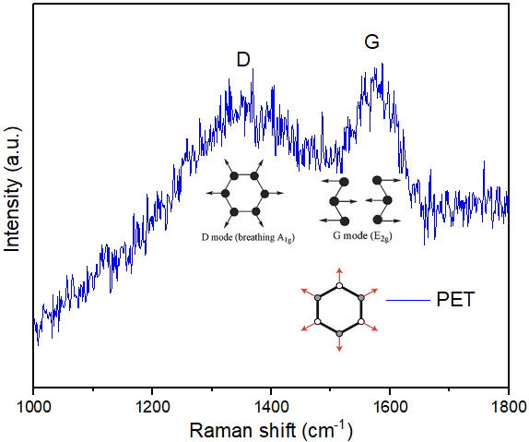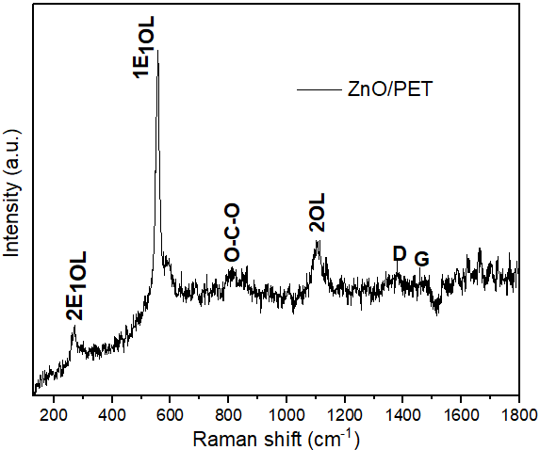
a)
b)
Figure 4. Raman spectra obtained for the PET-PP (a) and ZnO/PET-PP (b) samples. Characteristic vibrational bands associated with the E₁ first-order Raman-active polar optical phonon mode of ZnO are observed, which are further divided into transverse optical (TO) and longitudinal optical (LO) phonon modes, confirming the presence of ZnO nanoparticles on the polymer surface.
Figure 4 shows the Raman spectra of the ZnO/PET-PP nanostructures excited using a laser source with a wavelength of λ = 632 nm. A strong Raman peak was observed at 580 cm⁻¹, corresponding to the 1E₁(LO) mode (longitudinal optical phonon), which is associated with the first-order Raman-active polar optical E₁ phonon mode of the wurtzite ZnO crystal structure. This vibrational mode is further divided into transverse optical (TO) and longitudinal optical (LO) phonon components. The characteristic ZnO peak typically observed at 437 cm⁻¹ was not detected in the ZnO/PET-PP nanostructure, likely due to overlap with stronger resonant Raman scattering peaks, resulting in a shift of the dominant signal toward 580 cm⁻¹. Two main theories may explain the enhancement of the Raman signal intensity observed in the ZnO/PET-PP nanostructures: (1) the electromagnetic theory, which is based on the excitation of localized surface plasmons, and (2) the chemical theory, which attributes the enhancement to the formation of charge-transfer complexes and is applicable only to species chemically bonded to the surface. Raman intensity is directly related to the strength of the locally generated electric field, which can interact with optical phonons and enhance the scattering intensity of Raman-active vibrational modes. Therefore, the enhanced Raman response observed in the ZnO/PET-PP nanostructures can be attributed to the strong local electric field generated at the ZnO–PET-PP interface. The strength of the interaction between ZnO and PET-PP is governed by the induced polarization of both materials under the electric field arising from charge separation. This phenomenon occurs because positive ions remain on the PET-PP surface after electrons from the polyester functional groups are transferred to ZnO as a consequence of light-induced interfacial interactions. The resulting charge-transfer process promotes a stronger coupling between the inorganic nanoparticles and the polymer matrix, leading to the observed Raman enhancement.
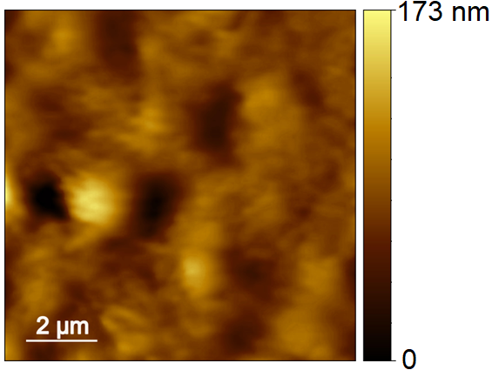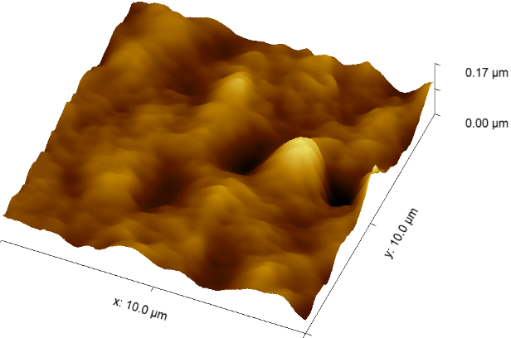
Ra= 2.92 nm
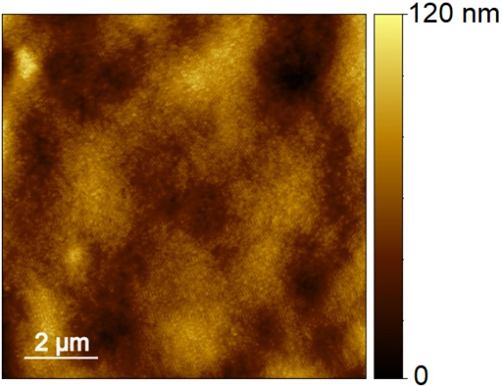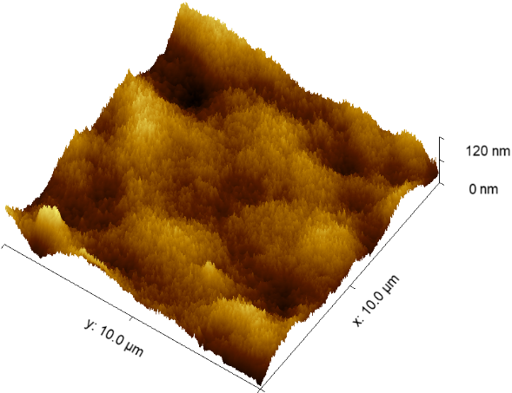
Ra= 2.36 nm
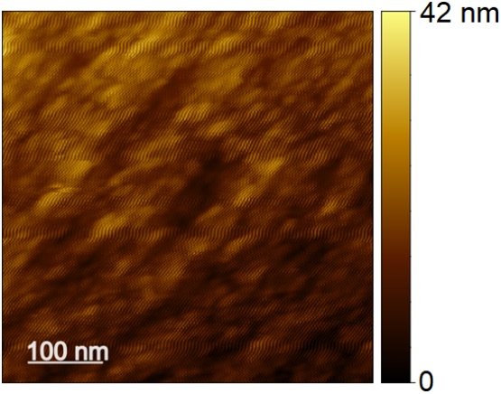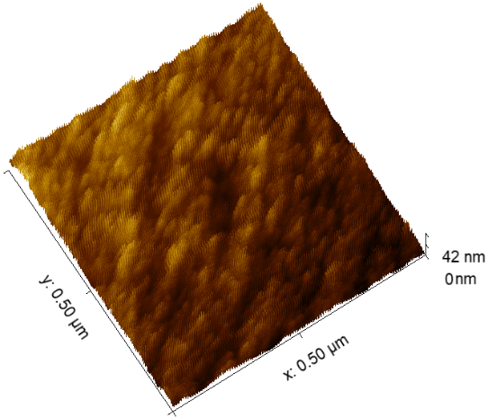
Ra= 1.84 nm
Figure 5. Atomic Force Microscopy (AFM) images of the PET-PP and ZnO/PET-PP samples. The analyses were conducted to investigate the surface topography and quantify changes in surface roughness induced by the incorporation of ZnO nanoparticles into the polymer matrix.
The AFM images presented in Figure 5 reveal the surface morphology and topographical characteristics of the PET–PP and ZnO/PET–PP samples after processing and nanoparticle incorporation. Both the two-dimensional and three-dimensional AFM micrographs show heterogeneous surface features composed of peaks and valleys distributed across the polymer matrix. The unmodified PET–PP sample exhibits relatively pronounced topographical irregularities, whereas the ZnO-coated material displays a more homogeneous surface morphology, indicating that the incorporation of ZnO nanoparticles influences the organization of the polymer surface.
The average surface roughness (Ra) values obtained from the analyzed regions were 2.92, 2.36, and 1.84 nm, demonstrating a progressive reduction in roughness after nanoparticle incorporation. This behavior suggests that ZnO nanoparticles promote a more uniform surface structure by partially filling surface depressions and reducing the amplitude of topographical fluctuations. The corresponding three-dimensional AFM reconstructions further support this observation, showing a decrease in the height variation of surface features and the formation of a more compact and continuous morphology.
The reduction in roughness may be attributed to interfacial interactions between the ZnO nanoparticles and the polymer matrix, which improve nanoparticle dispersion and favor the formation of a homogeneous coating layer. Such interactions are consistent with the Raman spectroscopy results, which indicated strong electronic coupling at the ZnO–PET interface. Furthermore, the more uniform distribution of nanoparticles across the polymer surface is expected to enhance the availability of active photocatalytic sites and improve the generation of reactive oxygen species under irradiation.
Overall, the AFM results confirm that the incorporation of ZnO nanoparticles significantly modifies the surface architecture of the recycled PET–PP matrix, leading to a smoother and more homogeneous topography. These structural changes are expected to contribute positively to the functional performance of the material, particularly in applications requiring photocatalytic and antibacterial activity.
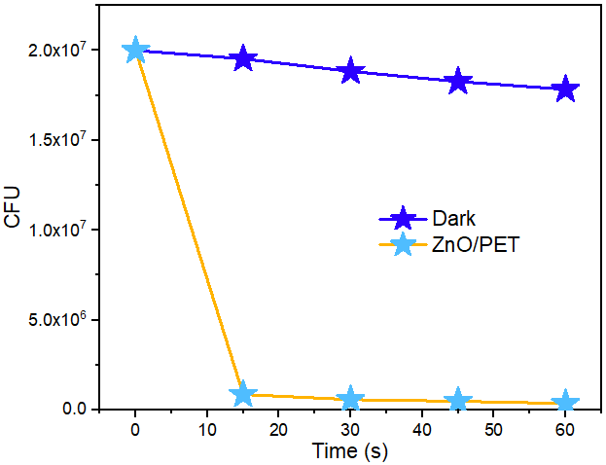
Figure 6. Antibacterial performance of the ZnO/PET-PP material against Escherichia coli (E. coli). The curves obtained under dark conditions (blue) and light irradiation (yellow) compare the bactericidal activity of the material. The experiment was designed to evaluate the photocatalytic antibacterial efficiency of the ZnO/PET-PP semiconductor under an irradiance of 60–65 mW cm⁻².
The antibacterial performance of the ZnO/PET–PP material against Escherichia coli is presented in Figure 6. The results clearly demonstrate a significant difference between the bacterial populations maintained under dark conditions and those exposed to light irradiation in the presence of the ZnO-coated polymer. Under dark conditions, the bacterial concentration decreased only slightly from approximately 2.0 × 10⁷ CFU to 1.8 × 10⁷ CFU during the 60 min experimental period, indicating that neither the polymeric substrate nor the environmental conditions alone were capable of producing substantial bacterial inactivation. This behavior confirms that the ZnO/PET–PP material exhibits limited antibacterial activity in the absence of photoactivation.
In contrast, when the ZnO/PET–PP sample was irradiated with light at an irradiance of 60–65 mW cm⁻², a dramatic reduction in bacterial viability was observed. Within the first 15 min of exposure, the bacterial concentration decreased by more than one order of magnitude, falling from approximately 2.0 × 10⁷ CFU to values below 1.0 × 10⁶ CFU. Continued irradiation resulted in a further decline in the number of viable cells, reaching near-complete bacterial inactivation after 60 min of treatment. The rapid decrease in colony-forming units demonstrates the strong photocatalytic antibacterial activity of the ZnO-coated polymeric surface.
The enhanced bactericidal effect under irradiation can be attributed to the photoactivation of ZnO nanoparticles. Upon absorption of photons with sufficient energy, electron–hole pairs are generated within the semiconductor. These charge carriers migrate to the ZnO surface, where they participate in oxidation and reduction reactions that produce reactive oxygen species (ROS), including hydroxyl radicals (•OH), superoxide radicals (•O₂⁻), and hydrogen peroxide intermediates. These highly reactive species attack the bacterial cell envelope, causing oxidative damage to membrane lipids, proteins, and intracellular biomolecules. Therefore, membrane permeability is disrupted, cellular metabolism is impaired, and bacterial death occurs.
The marked difference between the dark and illuminated experiments confirms that the antibacterial activity of the material is predominantly photocatalytic rather than intrinsic to the polymer matrix. Furthermore, the results demonstrate that the incorporation of ZnO nanoparticles onto recycled PET–PP surfaces successfully transform plastic waste into a functional material with advanced antimicrobial properties. This finding highlights the potential of combining recycled polymers with semiconductor nanomaterials to develop sustainable, value-added products for applications requiring self-disinfecting and antibacterial surfaces.
Conclusion
The present study demonstrates the successful transformation of recycled PET–PP waste into a functional antibacterial material through the integration of circular economy principles, nanotechnology, artificial intelligence, Internet of Things (IoT) technologies, and renewable-energy-based processing. The combination of recycled polymers and ZnO nanoparticles resulted in a photocatalytically active composite capable of effectively inactivating Escherichia coli under light irradiation, highlighting the potential of nanostructured polymeric materials for advanced antimicrobial applications.
The incorporation of ZnO nanoparticles significantly enhanced the functional properties of the recycled polymer matrix by introducing photocatalytic activity and promoting the generation of reactive oxygen species capable of damaging bacterial cell membranes. These results demonstrate that plastic waste can be converted into high-value-added products with functionalities that extend beyond those of conventional recycled materials, opening new opportunities for the development of next-generation polymeric composites.
From a circular economy perspective, this work provides a sustainable strategy for the valorization of plastic waste by reintegrating discarded PET and PP into productive cycles and transforming them into materials with improved technological performance. Such an approach contributes to reducing environmental pollution associated with plastic accumulation while simultaneously creating innovative products with potential applications in public health, environmental sanitation, and smart infrastructure.
An additional innovation of this project is the integration of Artificial Intelligence (AI) and Internet of Things (IoT) technologies for the identification and classification of microplastics using low-cost sensors. The implementation of intelligent monitoring systems enables automated detection and sorting processes, improving recycling efficiency and facilitating the development of smart waste management systems. The combination of AI-driven decision-making and IoT connectivity represents an important step toward the digitalization and optimization of future recycling infrastructures.
Furthermore, the electromagnetic induction heating system employed in this study offers a sustainable alternative to conventional thermal processing technologies. Because induction heating can be powered by renewable electricity sources such as solar and wind energy, the overall process reduces dependence on fossil fuels and lowers the environmental footprint associated with plastic transformation. The efficient and localized heat generation observed during processing further demonstrates the potential of induction technologies for energy-efficient recycling operations.
Overall, the convergence of recycled polymers, semiconductor nanomaterials, artificial intelligence, IoT-based monitoring systems, and renewable-energy-powered processing technologies establishes a multidisciplinary framework for the development of sustainable multifunctional materials. This approach not only promotes plastic waste valorization but also contributes to the advancement of smart manufacturing, resource efficiency, environmental protection, and the broader goals of the circular economy and sustainable development.
Referencias
- Leo H. Baekeland. "The Synthesis, Constitution, and Uses of Bakelite." Industrial and Engineering Chemistry 1 (1909): 149-161.
- Thompson, R. C., Swan, S. H., Moore, C. J., & Vom Saal, F. S. (2009). Our plastic age. Philosophical Transactions of the Royal Society B: Biological Sciences, 364(1526), 1973-1976.
- Dennis, L. (2024). A brief history of the use of plastics. Cambridge Prisms: Plastics, 2, e19.
- Meikle, J. L. (1995). American plastic: a cultural history. Rutgers University Press.
- Millican, J. M., & Agarwal, S. (2021). Plastic pollution: a material problem?. Macromolecules, 54(10), 4455-4469.
- MacLeod, M., Arp, H. P. H., Tekman, M. B., & Jahnke, A. (2021). The global threat from plastic pollution. Science, 373(6550), 61-65.
- Thushari, G. G. N., & Senevirathna, J. D. M. (2020). Plastic pollution in the marine environment. Heliyon, 6(8).
- Williams, A. T., & Rangel-Buitrago, N. (2022). The past, present, and future of plastic pollution. Marine Pollution Bulletin, 176, 113429.
- Chu, J., Hu, X., Kong, L., Wang, N., Zhang, S., He, M., ... & Lin, C. (2021). Dynamic flow and pollution of antimony from polyethylene terephthalate (PET) fibers in China. Science of the Total Environment, 771, 144643.
- Rodríguez-Hernández, A. G., Muñoz-Tabares, J. A., Aguilar-Guzmán, J. C., & Vazquez-Duhalt, R. (2019). A novel and simple method for polyethylene terephthalate (PET) nanoparticle production. Environmental Science: Nano, 6(7), 2031-2036.
- Nisticò, R. (2020). Polyethylene terephthalate (PET) in the packaging industry. Polymer Testing, 90, 106707.
- Ortega, D. E., & Cortés-Arriagada, D. (2023). Atmospheric microplastics and nanoplastics as vectors of primary air pollutants-A theoretical study on the polyethylene terephthalate (PET) case. Environmental Pollution, 318, 120860.
- Chang, X., Xue, Y., Li, J., Zou, L., & Tang, M. (2020). Potential health impact of environmental micro‐and nanoplastics pollution. Journal of Applied Toxicology, 40(1), 4-15.
- Ng, E. L., Lwanga, E. H., Eldridge, S. M., Johnston, P., Hu, H. W., Geissen, V., & Chen, D. (2018). An overview of microplastic and nanoplastic pollution in agroecosystems. Science of the total environment, 627, 1377-1388.
- Rout, P. R., Mohanty, A., Sharma, A., Miglani, M., Liu, D., & Varjani, S. (2022). Micro-and nanoplastics removal mechanisms in wastewater treatment plants: A review. Journal of Hazardous Materials Advances, 6, 100070.
- Hopewell, J., Dvorak, R., & Kosior, E. (2009). Plastics recycling: challenges and opportunities. Philosophical Transactions of the Royal Society B: Biological Sciences, 364(1526), 2115-2126.
- Garcia, J. M., & Robertson, M. L. (2017). The future of plastics recycling. Science, 358(6365), 870-872.
- Agenda, I. (2016, January). The new plastics economy rethinking the future of plastics. In The World Economic Forum: Geneva, Switzerland (Vol. 36).
- Li, H., Aguirre-Villegas, H. A., Allen, R. D., Bai, X., Benson, C. H., Beckham, G. T., ... & Huber, G. W. (2022). Expanding plastics recycling technologies: chemical aspects, technology status and challenges. Green Chemistry, 24(23), 8899-9002.
- Kurniawan, T. A., Othman, M. H. D., Hwang, G. H., & Gikas, P. (2022). Unlocking digital technologies for waste recycling in Industry 4.0 era: A transformation towards a digitalization-based circular economy in Indonesia. Journal of Cleaner Production, 357, 131911.
- Vollmer, I., Jenks, M. J., Roelands, M. C., White, R. J., Van Harmelen, T., De Wild, P., ... & Weckhuysen, B. M. (2020). Beyond mechanical recycling: giving new life to plastic waste. Angewandte Chemie International Edition, 59(36), 15402-15423.
- Su, J., Li, T., Xie, W., Wang, C., Yin, L., Yan, T., & Wang, K. (2023). Emerging technologies for waste plastic treatment. ACS Sustainable Chemistry & Engineering, 11(22), 8176-8192.
- Duong-Viet, C., Truong-Phuoc, L., Nguyen-Dinh, L., Michon, C., Nhut, J. M., Pham, C., ... & Pham-Huu, C. (2023). Magnetic induction assisted pyrolysis of plastic waste to liquid hydrocarbons on carbon catalyst. Materials Today Catalysis, 3, 100028.
- Selvam, E., Yu, K., Ngu, J., Najmi, S., & Vlachos, D. G. (2024). Recycling polyolefin plastic waste at short contact times via rapid joule heating. Nature Communications, 15(1), 5662.
- Rudnev, V., Loveless, D., Cook, R. L. (2017). Handbook of Induction Heating. United Kingdom: CRC Press.
- Lucia, O., Maussion, P., Dede, E. J., & Burdío, J. M. (2013). Induction heating technology and its applications: past developments, current technology, and future challenges. IEEE Transactions on industrial electronics, 61(5), 2509-2520.
- Vishnuram, P., Ramachandiran, G., Ramasamy, S., & Dayalan, S. (2020). A comprehensive overview of power converter topologies for induction heating applications. International Transactions on Electrical Energy Systems, 30(10), e12554.
- Manjula, B., Reddy, A. B., Sadiku, E. R., Sivanjineyulu, V., Molelekwa, G. F., Jayaramudu, J., & Kumar, K. R. (2017). Use of polyolefins in hygienic applications. In Polyolefin Fibres (pp. 539-560). Woodhead Publishing.
- Zhang, E., Zhao, X., Hu, J., Wang, R., Fu, S., & Qin, G. (2021). Antibacterial metals and alloys for potential biomedical implants. Bioactive materials, 6(8), 2569-2612.
- Lin, N., Berton, P., Moraes, C., Rogers, R. D., & Tufenkji, N. (2018). Nanodarts, nanoblades, and nanospikes: Mechano-bactericidal nanostructures and where to find them. Advances in colloid and interface science, 252, 55-68.
- Ríos‐Castillo, A. G., González‐Rivas, F., & Rodríguez‐Jerez, J. J. (2017). Bactericidal efficacy of hydrogen peroxide‐based disinfectants against Gram‐positive and Gram‐negative bacteria on stainless steel surfaces. Journal of Food Science, 82(10), 2351-2356.
- Tiwari, V., Mishra, N., Gadani, K., Solanki, P. S., Shah, N. A., & Tiwari, M. (2018). Mechanism of anti-bacterial activity of zinc oxide nanoparticle against carbapenem-resistant Acinetobacter baumannii. Frontiers in microbiology, 9, 1218.
- Qi, K., Cheng, B., Yu, J., & Ho, W. (2017). Review on the improvement of the photocatalytic and antibacterial activities of ZnO. Journal of Alloys and Compounds, 727, 792-820.

